CURRENT BUFFERING USING OP-AMP 6203

Introduction:
A current buffer amplifier is an amplifier used to transfer current from one circuit having a lower impedence level to a circuit having a higher impedence level without interfering with its desired operation. For a current buffer, if the current transferred is unchanged (current gain is 1). The amplifier is a unity gain buffer also called as a current follower since the output current follows the input current.

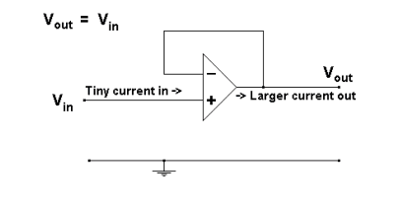

About the op-amp:
The LT6202/LT6203/LT6204 are single/dual/quad low noise, rail-to-rail input and output unity gain stable op amps that feature 1.9nV/√Hz noise voltage and draw only 2.5mA of supply current per amplifier. These amplifiers combine very low noise and supply current with a 100MHz gain bandwidth product, a 25V/µs slew rate, and are optimized for low supply signal conditioning systems. These amplifiers maintain their performance for supplies from 2.5V to 12.6V and are specified at 3V, 5V and ±5V supplies. Harmonic distortion is less than –80dBc at 1MHz making these amplifiers suitable in low power data acquisition systems.

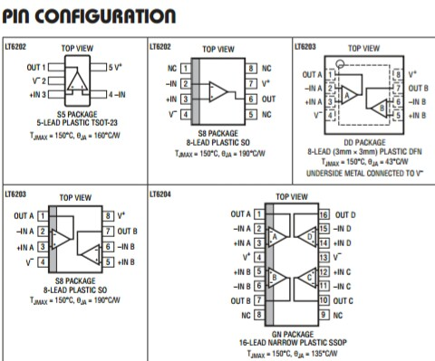

Features:
Low Noise Voltage: 1.9nV/√Hz (100kHz)
Low Supply Current: 3mA/Amp Max
Gain Bandwidth Product: 100MHz
Dual LT6203 in Tiny DFN Package
Low Distortion: –80dB at 1MHz
Applications:
Low Noise, Low Power Signal Processing
Active Filters
Rail-to-Rail Buffer Amplifiers
Driving A/D Converters
DSL Receivers
Battery Powered/Battery Backed Equipment

About the transistor:
Features:
Suitable for middle power driver
Low V_{ce(sat)}=350mV
(I_{c}/I_{b}= 500mA/25mA)

Schematic and Simulation Working:

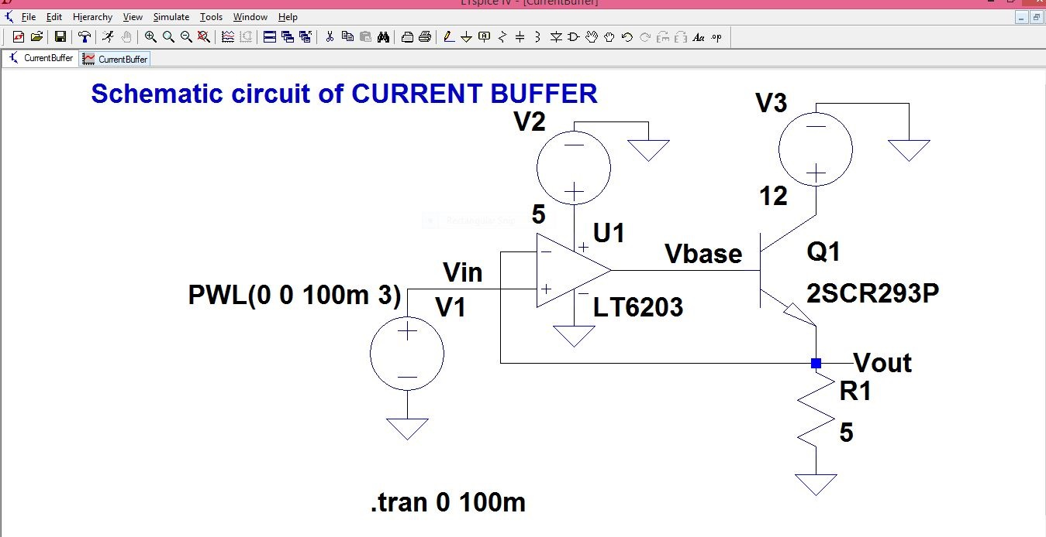
Fig 1.

The input signal is applied to the non inverting op-amp terminal and the output terminal is along one of the terminal of the BJT. The value of the load resistance is kept low such that the output voltage of greater magnitude applied directly to the load would require more output current. The NPN driver transistor is chosen such that it can handle higher magnitude of currents. In particular the transistor 2SCR293P can handle about 1000mA, which means it is good for load voltages upto 5V. The negative feedback of the op-amp compensates for the non linearity of the BJT’s base to emitter voltage.

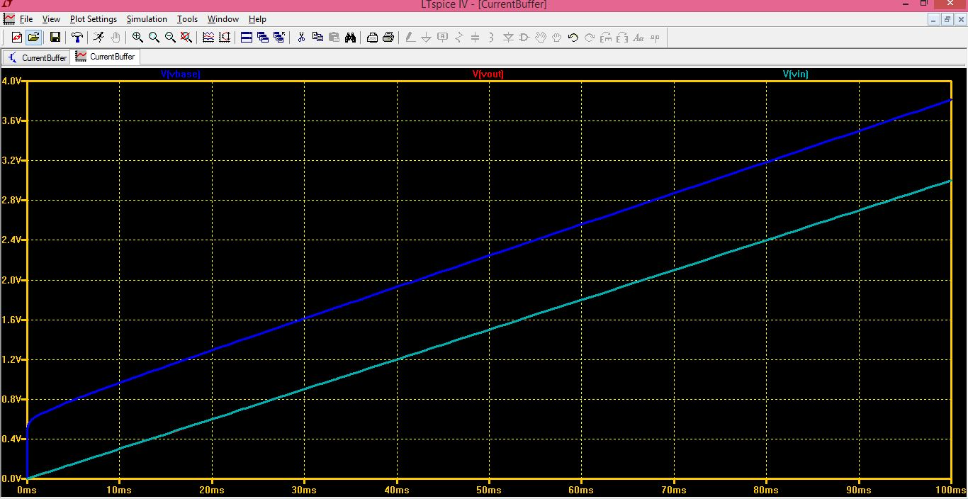
Fig2.

The schematic in Fig1. Is a special case of current buffer i.e. the current follower. The output simply follows the input and the current gain is unity. Quite obvious from the simulation window in Fig2. Where the piecewise linear waveform (PWL) of the input is superimposed upon that of the output.

In the schematic in Fig.3 there are some additional resistors added which produce a higher gain. (A= 1+(R₂/R₃)) since both resistors have equal in value, the gain goes up to 2. The changes of a higher output in voltage and therefore a higher rise in current is noticeable in Fig.4.
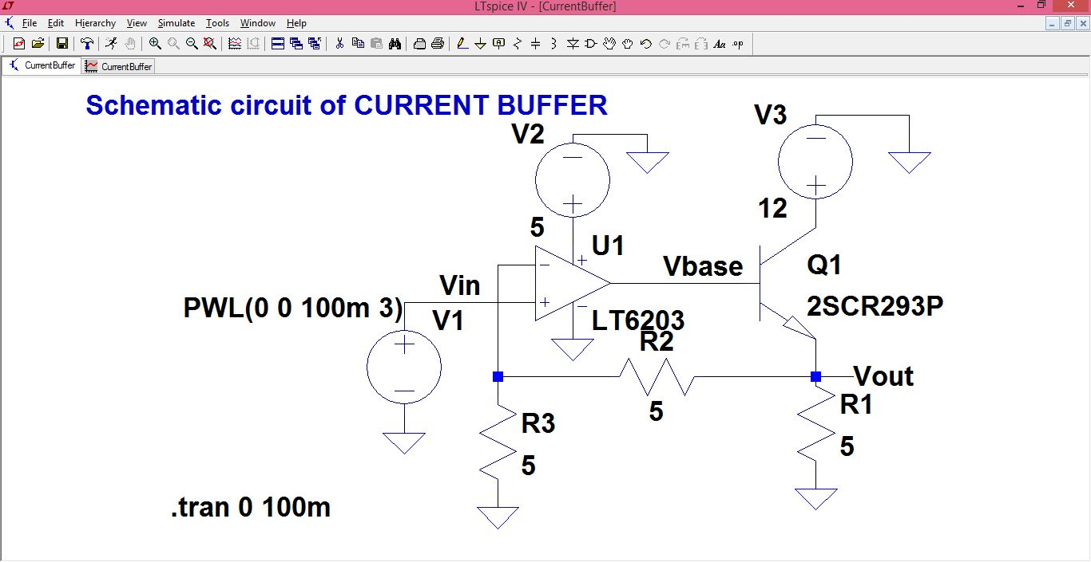
Fig3.

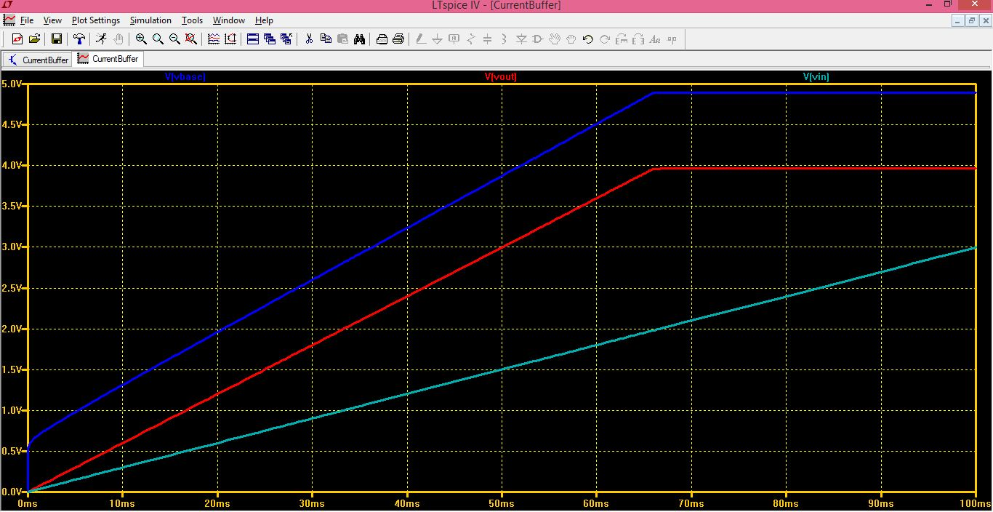
Fig4.

Applications:
A buffer is packed in an integrated circuit and its function is to provide sufficient drive capability to pass signals or data bits along to a succeeding stage.

